**Project On SQL**

-- create a database

create database projectswadesh;

use projectswadesh;

SHOW VARIABLES LIKE "secure_file_priv";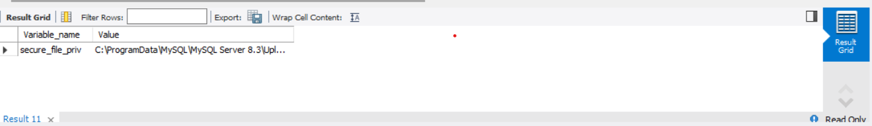create table olympics

(

ID int,

Name varchar(300),

Sex char(10),

Age int,

Height int,

Weight int,

Team varchar(200),

NOC varchar(200),

Games varchar(200),

Year int,

Season varchar(200),

City varchar(100),

Sport varchar(200),

Event varchar(250),

Medal varchar(50)

);

select * from olympics;

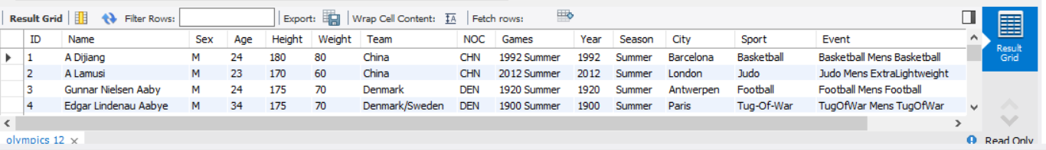

load data infile 'C:/ProgramData/MySQL/MySQL Server 8.3/Uploads/Athletes_Cleaned.csv'

into table olympics

fields terminated by ','

enclosed by'"'

lines terminated by '\r\n'

ignore 1 rows;

-- SQL PROJECT

-- 1. Show how many medal counts present for entire data

select medal,count(medal) as count_medal

from olympics

where medal <> 'NoMedal'

group by medal;

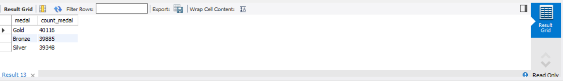

-- 2. Show count of unique sports present in Olympics

select sport, count(distinct(sport))

from olympics

group by sport; 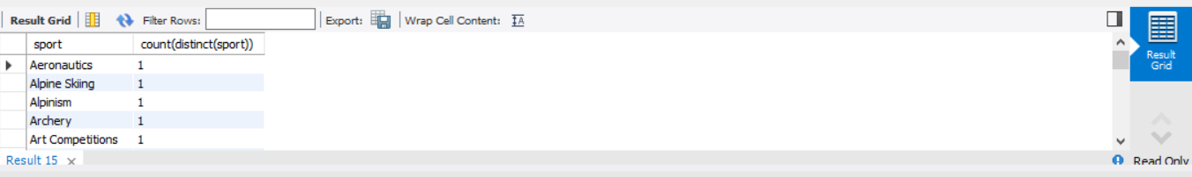

-- 3. Show how many different medals won by team India

select Team, medal,count(medal) as medalcount

from olympics

where Team='India' AND medal <> 'Nomedal'

group by Team,medal;

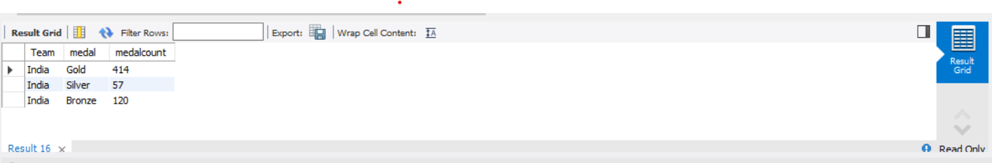

-- 4. Show event wise medals won by India show from highest to lowest medals won in order

select Team,Event,medal, count(medal) as medalcount

from olympics

where Team = 'India' AND medal <> 'Nomedal'

group by Team,Event,medal

order by medalcount desc;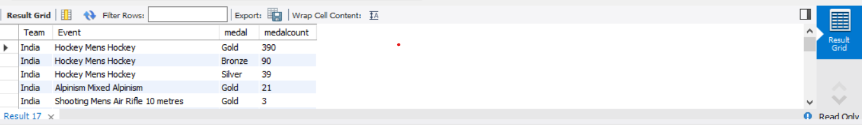

-- 5. Show event wise medals won by India in order of year

select event,year medal,Team from olympics

where Team= 'india' and Medal <> 'Nomedal'

group by event,year,medal

order by year; 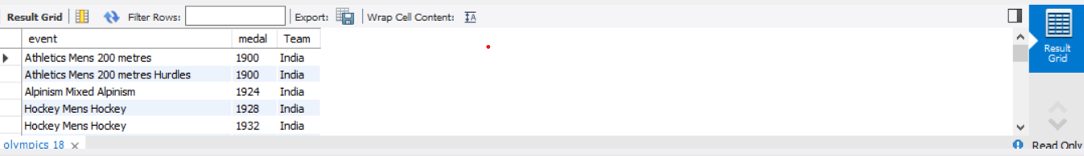

-- 6. show country who won maximum medals.

select Team,medal,count(medal) as medalcount

from olympics

where medal<> 'Nomedal'

group by Team,medal

order by medalcount desc;

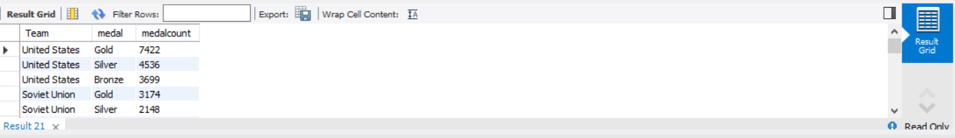

-- 7.show top 10 countries whowon gold

select Team,medal,count(medal) as medalcount

from olympics

where medal ='Gold'

group by Team,medal

order by medalcount desc

limit 10;

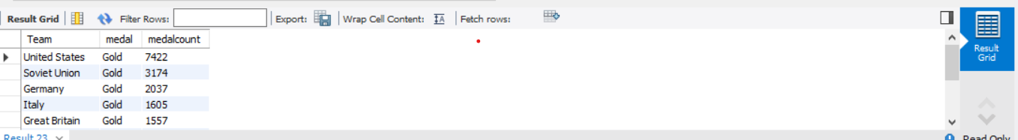

-- 8. show in which year did United states won most gold medal

select Team,year,medal,count(medal) as medalcount from olympics

where Team='United States' AND Medal <> 'Nomedal'

group by year,medal

order by medalcount desc;

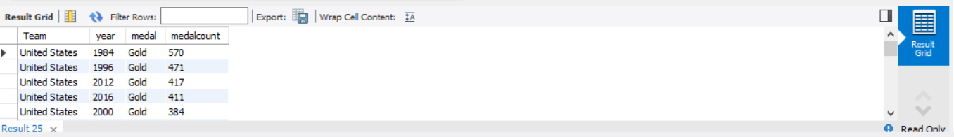

-- 9. In which sports United States has most medals.

select Team,sport,medal,count(medal) as medalcount from olympics

where Team ='United States' AND Medal <> 'Nomedal'

group by team,sport,medal

order by medalcount desc;

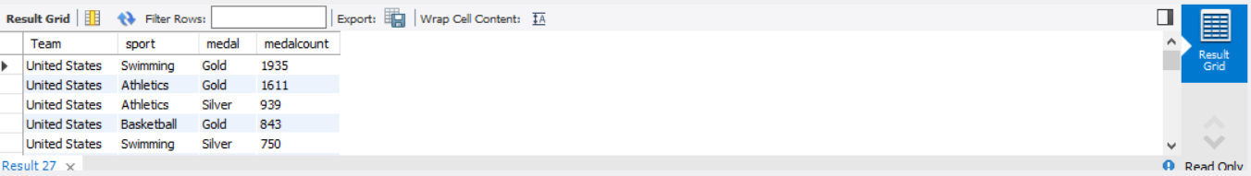

-- 10. Find top three players who won most medals along with their sports and country

select name,sport,team, count(medal) as medalcount from olympics

where medal <> 'Nomedal'

group by name,sport,medal,team

order by medalcount desc

limit 3;

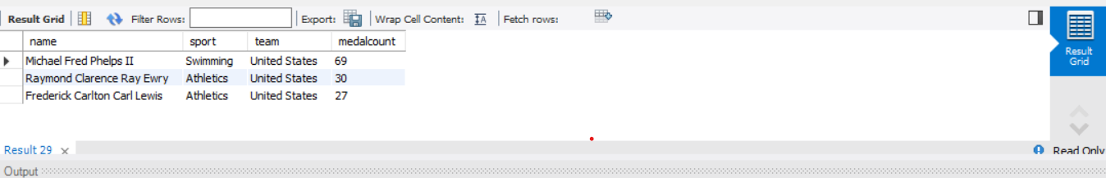

-- 11. Find player with most gold medals in cycling along with his country.

select name,medal,sport,Team,count(medal) as medalcount from olympics

where sport='Cycling' AND medal ='Gold'

group by name,medal,sport,Team

order by medalcount desc limit 1;

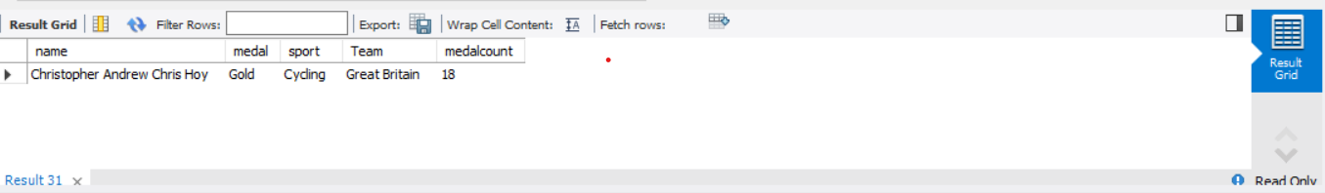

-- 12.Find player with most medals (Gold+Silver+Bronze) in Basketball also show his country.

select team,name,sport,medal,count(medal) as medalcount from olympics

where sport='basketball' and medal <> 'Nomedal'

group by team,name,sport,medal

order by medalcount desc;

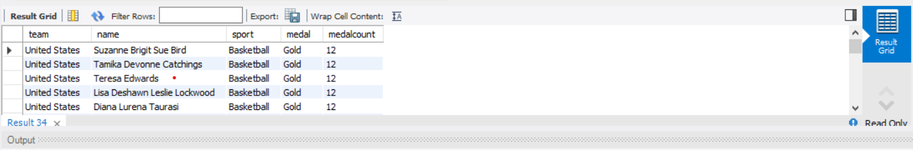

-- 13. Find out the count of different medals of the top basketball player Teresa Edwards

select name,sport,medal,count(medal) from olympics

where sport='basketball' and name='Teresa Edwards'

group by name,sport,medal;

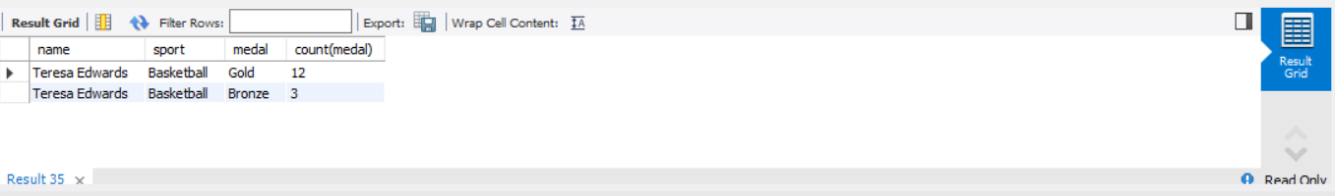

-- 14. Find out medals won by male,female each year , Export this data and plot graph in excel

select sex,year,medal,count(medal) from olympics

where medal <> 'Nomedal'

group by sex,year,medal

order by sex,year,medal;

